

**AMERICAN INTERNATIONAL UNIVERSITY-BANGLADESH**

Faculty of Science and Technology (FST)

Department of Computer Science (CS)

**SOFTWARE ENGINEERING**

Section: I

Topic: Project

Project Title : **3D Model Based Product Customization in Virtual Reality Store**

**Submitted to : “Tonny Shekha Kar” Mam**

**Submitted By :**

|  |  |  |
| --- | --- | --- |
| **Name** | **Id** | **Degree Program** |
| **SANVIRAJ AYNUL SIAM** | **21-45837-3** | **BSc CSE** |
| **SAROWAR JAHAN PROTIK** | **21-45556-3** | **BSc CSE** |
| MD. ZAHID SADMAN SAKIB | **21-45904-3** | **BSc CSE** |
| **MD. SHANJID HASAN ABIR** | **21-45785-3** | **BSc CSE** |

**Title: 3D Model Based in Virtual Reality Environment for Product Customization in E-commerce Applications**

**1. Problem Statement:**

Design and implement a software prototype for enabling customization of 3D representation of products in a virtual reality store. The solution should allow users to interactively modify product designs in a virtual environment and visualize the customized products in real-time before making a purchase.

**2. Literature Review:**

One of the most promising application areas of virtual reality (VR) in a business context is considered to be shopping and retail. Retail giants such as Amazon (VR kiosks), Alibaba (Buy + mobile VR platform), eBay (VR Department Store app) and IKEA (virtual reality kitchen showroom) have been making effort to embed virtual reality into their e-commerce services and trying to transform the future of the shopping ecosystem. VR technology is thus believed to solve limitations of space and time and to enable the replication and creation of any shopping environment that is accessible for consumers at any time. Beyond an alluded-to increased overall cost-efficiency of shopping, VR is especially being touted because of the belief that it can enrich the shopping experience beyond that of brick-and-mortar shopping, as it is believed to afford a more immersive experience that can be further augmented with similar information retrieval systems as found in web-based shopping. It is evident that VR technology is shaping consumer-to-business relationships, and therefore creating huge market value in the retail and marketing sectors (Nannan et. al., 2021).

**3. Functionalities:**

|  |  |  |  |
| --- | --- | --- | --- |
| **Function** | **What is augmented?**  **(real object)** | **What is attached?**  **(virtual object)** | **Example** |
| Informing | Product | Information | Virtual nutrition scores attached to food packaging |
| Visualizing | Marker (of the product) | Visualization of the product | Virtual model of an automobile attached to a catalogue |
| Trying-on | Consumer | Embedded product | Virtual sunglasses attached to the consumers’ face |
| Placing | Consumer’s environment | Embedded product | Virtual furniture attached to the consumers’ living room |

**3.1 3D Model Rendering**: A robust rendering engine capable of displaying high-quality 3D models in real-time.

**3.2 Customization Interface**: Develop an intuitive user interface for modifying product attributes such as color, size, texture, and shape.

**3.3 Real-time Visualization**: Enable users to preview their customizations instantly within the e-commerce platform.

**3.4 Integration with E-commerce Platform**: Integrate the customization tool seamlessly with existing e-commerce websites or applications.

**3.5 Customization Persistence**: Ensure that user-customized products can be saved and retrieved for future reference.

**3.6 Compatibility**: Ensure compatibility across different devices and web browsers for a seamless user experience.

**4. Target Users:**

Some functionalities may beneﬁt speciﬁc product categories (e.g., trying-on for apparel, informing for food). Based on the current state-of-art and available technology to public the followings are our target user:

1. Apparel customer

2. Sunglass and prescription glass customer

3. Watch customer

4. Shoe Customer

5. Furniture customer

6. Home interior design customer

**5. Conclusion:**

In conclusion, the implementation of a 3D model-based product customization solution in e-commerce applications offers significant potential for enhancing user engagement and driving sales. By empowering consumers to personalize their purchases, businesses can differentiate themselves in a competitive market while also streamlining the production process through efficient design validation.

**6. References**

1. “Consumer behavior in augmented shopping reality. A review, synthesis, and research agenda”. Stefan Hoffmann and Robert Mai (2022). doi:10.3389/frvir.2022.961236

2. “Shopping in virtual reality: A literature review and future agenda”. Nannan Xi, Juho Hamari (2021). doi:[10.1016/j.jbusres.2021.04.075](https://doi.org/10.1016/j.jbusres.2021.04.075)

Description of Student’s Contribution in the Project work

|  |
| --- |
| Student Name: Md. Zahid Sadman Sakib  Student ID: 21-45904-3  Contribution in Percentage (%):  Contribution in the Project:   * Existing Studies and Relevant Example * Project Background Analysis and Feasibility   ___________________  Signature of the Student |
| Student Name: Sarowar Jahan Protik  Student ID: 21-45556-3  Contribution in Percentage (%):  Contribution in the Project:   * Process Model Selection * Project Role Identification and Responsibilities   ___________________  Signature of the Student |
| Student Name: Sanviraj Siam  Student ID: 21-45837-3  Contribution in Percentage (%):  Contribution in the Project:   * Project Role Identification and Responsibilities * Process Model Selection   ___________________  Signature of the Student |
| Student Name: Md. Shanjid Hasan Abir  Student ID: 22-47202-1  Contribution in Percentage (%):  Contribution in the Project:   * Project Background Analysis and Feasibility * Impact   ___________________  Signature of the Student |

# Project Background Analysis and Feasibility

# Virtual reality (VR) is one of several digital technologies that could be considered useful in developing the new concept of retail stores where traditional and digital store elements co-exist. Along with other interactive technologies, such as augmented reality (AR) and mixed reality, VR is shaping a new environment (space) where physical and augmented/virtual objects/elements are integrated in different ways (Flavián et al., 2019). Retailing is considered one of the sectors with the greatest possibilities to implement AR (Cruz et al., 2018). As highlighted by Javornik (2016a, b), the VR industry is estimated to reach $56.8bn globally by 2020, and in the retail market, it is expected to reach almost $7.9bn globally by 2023 (Markets and Markets, 2018) [1]. These global data support the positive expectations of the future of this technology. VR has the potential to modify the shopping experience (Watson et al., 2018). Increases in online shopping (Barlow et al., 2004), smartphone use and the adoption of connected devices are major factors driving the growth of VR in retail markets by encouraging retailers to adopt VR. Thus, retailers are increasingly embracing VR applications as a tool for creating immersive customer experiences (Flavián et al., 2019; Watson et al., 2018).

## 1.2 Impact

**Health Issues:** Virtual reality sickness, also known as VR sickness or cybersickness, occurs when exposure to a virtual environment causes symptoms similar to motion sickness. The most common symptoms include general discomfort, eye strain, headache, stomach awareness, nausea, vomiting, pallor, sweating, fatigue, drowsiness, disorientation, and apathy. This sickness can be triggered by a disparity in apparent motion between the visual and vestibular stimuli, which occurs if there is a disagreement between what the stimuli from the eyes and inner ear are sending to the brain.

**Legal Issues:** Virtual reality stores present several legal challenges. One major issue is the question of ownership rights for digital goods created or purchased within the virtual environment. Additionally, the immersive and highly realistic nature of virtual reality can lead to legal concerns related to intellectual property rights, such as trademark and copyright, and the potential for cyberspace crimes.

**Personalization:** Virtual reality stores can offer a highly personalized shopping experience by tailoring the store layout, product recommendations, and promotions to each individual’s preferences and shopping history. This level of personalization can enhance customer satisfaction and loyalty, as customers feel valued and understood by the brand.

**Interactivity:** Virtual reality stores provide an interactive shopping experience where customers can engage with products in a 3D environment, offering a level of engagement that traditional online shopping can’t match. This interactivity can lead to increased customer engagement and higher conversion rates.

**Less Return:** With virtual reality, customers can try products before buying, reducing the likelihood of returns due to mismatched expectations. This can save both the customer and the retailer time and money associated with handling returns.

**Virtual Try On:** Virtual reality stores can offer a “virtual try-on” feature, allowing customers to see how clothes, accessories, or even furniture might look on them or in their home before making a purchase. This can increase customer confidence in their purchases and lead to higher customer satisfaction.

**Accessibility:** Virtual reality stores can be accessed from anywhere at any time, making shopping more convenient for customers, especially those who may have difficulty visiting physical stores. This accessibility can broaden the store’s customer base and increase sales.

**Brand Engagement:** Virtual reality stores offer unique and immersive experiences that can strengthen customer engagement with the brand. This can increase brand loyalty and advocacy, leading to higher customer lifetime value and more positive word-of-mouth referrals.

**1.3 Existing Studies and Relevant Example**

|  |  |  |
| --- | --- | --- |
| Application | AR feature Description | Image |
| ASOS | ASOS AR search product feature. Users can take an image of an item with their smartphone's camera and search for the item (or similar item) on the ASOS app. This blends the real world with the virtual world enabling users to search for a product with an image in front of them from their real-world environment. |  |
| Amazon | Amazon's AR search product feature enables users to take an image with their smartphone's camera of an ‘actual’ product or scan the product's barcode to find the item (or similar item) on Amazon. This experience blends the real world with the virtual world. |  |
| IKEA | The IKEA AR product selection enables users to select a product from the IKEA app catalogue to place in their own home. Through the camera view on the individual's smartphone the app enables the user to integrate computer generated objects with the real world and provide individuals with real-time interactions. This enables the user to manipulate the product in the virtual environment while overlaid on the real world environment. An example of the IKEA AR product overlay feature: This user has placed a floor-standing lamp in their living room. The view in the image is the view the user sees through their in- phone camera on the IKEA Place app. |  |

1. Flavián, C., Ibáñez-Sánchez, S. and Orús, C. (2019), “The impact of virtual, augmented and mixed reality technologies on the customer experience”, Journal of Business Research, Vol. 100, July, pp. 547-560.

2. Cruz, E., Orts-Escolano, S., Gomez-Donoso, F., Rizo, C., Rangel, J.C., Mora, H. and Cazorla, M. (2018), “An augmented reality application for improving shopping experience in large retail stores”, Virtual Reality, pp. 1-11, available at: <https://doi.org/10.1007/s10055-018-0338-3>

3. Javornik, A. (2016a), “Augmented reality: research agenda for studying the impact of its media characteristics on consumer behavior”, Journal of Retailing and Consumer Services, Vol. 30, pp. 252-261, available at: http://dx.doi.org/10.1016/j.jretconser.2016.02.004

4. Javornik, A. (2016b), “It’s an illusion, but it looks real! Consumer affective, cognitive and behavioural responses to augmented reality applications”, Journal of Marketing Management, Vol. 32 Nos 9-10, pp. 987-1011.

5. Barlow, A.K., Siddiqui, N.Q. and Mannion, M. (2004), “Developments in information and communication technologies for retail marketing channels”, International Journal of Retail & Distribution Management, Vol. 32 No. 3, pp. 157-163.

6. Watson, A., Alexander, B. and Salavati, L. (2018), “The impact of experiential augmented reality applications on fashion purchase intention”, International Journal of Retail & Distribution Management, available at: <https://doi.org/10.1108/IJRDM-06>

## 2. Process Model Selection

The **Scrum** model would be a suitable Agile methodology for building a virtual reality store for the following reasons:

**2.1. Sprints**: Scrum operates in sprints, which are time-boxed iterations that typically last 2-4 weeks. This allows the team to deliver features incrementally and receive feedback quickly, which is crucial for a virtual reality store project where user experience is paramount.

**2.2. Roles and Responsibilities**: Scrum clearly defines roles (Product Owner, Scrum Master, Development Team), which can bring clarity and focus to the development process. The Product Owner can continuously prioritize the backlog based on market trends in the rapidly evolving field of virtual reality.

**2.3. Adaptability**: Scrum is designed to embrace change. As the virtual reality market is still evolving, requirements might change frequently. Scrum allows the team to adapt to these changes smoothly.

**2.4. Inspection and Adaptation**: Scrum events like Daily Scrum, Sprint Review, and Sprint Retrospective provide opportunities for the team to inspect the work and adapt the plan, ensuring continuous improvement.

**2.5. Visibility and Progress Tracking**: Tools like the Product Backlog, Sprint Backlog, and Burndown Charts provide visibility into the progress, helping manage expectations and keeping stakeholders informed.

## 3. Project Role Identification and Responsibilities

**3.1. Project Management:**

**Project Manager:**

* Define project scope, goals, budget, and timeline.
* Manage development team, including assigning tasks, tracking progress, and resolving conflicts.
* Facilitate communication between stakeholders and ensure everyone is aligned.
* Manage risks and contingencies.
* Conduct testing and quality assurance.
* Track and report project metrics.

**Technical Project Manager:**

* Oversee technical aspects of the project, including architecture, integration, and technology selection.
* Work with developers to create technical specifications and manage technical risks.
* Ensure VR platform compatibility and performance optimization.

**3.2. Development Team:**

**VR Developers:**

* Build the virtual store environment, including 3D modeling, texture mapping, and lighting.
* Develop interactive elements and user interface within the VR experience.
* Integrate backend systems for product data, shopping cart functionality, and payment processing.
* Optimize code for VR performance and user experience.

**Software Developers:**

* Develop backend server-side components for data management, user authentication, and transaction processing.
* Integrate virtual store with existing e-commerce platform (if applicable).
* Build APIs for communication between VR frontend and backend systems.

**Quality Assurance Testers**:

* Test VR store functionality across different VR headsets and platforms.
* Identify and report bugs and usability issues.
* Ensure smooth navigation, interaction, and product visualization.

**3.3. Design and Content:**

**3D Design Artists:**

* Create 3D models of products, environment, and other visual elements.
* Ensure visual consistency and brand adherence within the VR space.
* Design intuitive and interactive UI elements for smooth navigation.

**Content Strategists:**

* Develop content strategy for product descriptions, promotions, and marketing materials within the VR store.
* Ensure content is optimized for VR experience and user accessibility.

**3.4. Business and Marketing:**

**Product Owners:**

* Define product vision, features, and user experience for the VR store.
* Prioritize requirements and features based on business goals and user needs.
* Provide feedback and approval throughout the development process.

**Marketing Team:**

* Develop marketing strategies to promote the VR store launch and attract users.
* Create VR-specific marketing materials and promotional content.
* Analyze user behavior and engagement within the VR store.

**3.5. External Partners:**

**VR Platform Providers (e.g., Oculus, HTC Vive):**

* Provide technical support and guidance for platform-specific development.
* Ensure compliance with platform guidelines and requirements.

**Payment Processing Companies:**

* Integrate secure payment processing solutions within the VR store.
* Ensure compliance with data security regulations.

**Additional Roles:**

* Security Expert: Ensures data security and privacy within the VR store.
* Accessibility Specialist: Designs VR store for accessibility and usability by users with disabilities.
* Customer Support: Assists users with technical issues and questions within the VR store.

**Software Requirement specification (SRS) for  3D Model Based Product Customization in Virtual Reality Store.**

**1.Introduction:**

**1.1 Purpose:** The main goal of the project "3D Model Based Product Customization in Virtual Reality Store" is to improve the virtual reality shopping experience by enabling users to personalize products in a virtual setting using 3D models. With this, users will be able to customize things more deeply and interactively to suit their tastes, which should boost customer happiness and maybe raise the virtual store's conversion rates.

**1.2 Scope of 3d model base:** The scope of a 3D model-based product customization project in a virtual reality store involves creating an immersive VR environment, integrating a diverse product catalog, implementing customization features, ensuring realistic rendering, facilitating user interaction and feedback, integrating with e-commerce functionality, incorporating social interaction features, optimizing performance, conducting testing and iteration, and planning for scalability and maintenance.

**2.Overview:**

**2.1 An Explanation:** This system utilizes virtual reality to offer users immersive product customization through interactive 3D models. Users can personalize items like clothing or furniture in real-time within the virtual store environment, enhancing the shopping experience. Seamless order placement and continual user feedback drive optimization for a dynamic and engaging platform.

**2.1 Architecture:**1**.** Fronted **Interface.**

**2.** **3D Model Repository.**

**3.** **Database.**

**4.** **VR Interaction Controls.**

**5.** **Scalability and Maintenance.**

**6.** **Security Measures.**

**7.** **Cross-Platform Compatibility.**

**8.** **Payment Gateway Integration.**

**9.User Account Management.**

**10.** **Data Backup and Recovery.**

**3. Functional Requirement:**

**3.1 3D Model Rendering**:  A robust rendering engine capable of displaying high-quality 3D models in real-time.

**3.2 Customization Interface**: Develop an intuitive user interface for modifying product attributes such as color, size, texture, and shape.

**3.3 Real-time Visualization**: Enable users to preview their customizations instantly within the e-commerce platform.

**3.4 Integration with E-commerce Platform**: Integrate the customization tool seamlessly with existing e-commerce websites or applications.

**3.5 Customization Persistence**: Ensure that user-customized products can be saved and retrieved for future reference.

**3.6 Compatibility**: Ensure compatibility across different devices and web browsers for a seamless user experience.

**4.Non-Functional Requirement:**

* **Rendering Speed**: The system should render 3D models quickly and efficiently to maintain smooth navigation and customization.

• **Reliability**:

* **Availability**: When it comes to maintenance or unplanned malfunctions, the virtual reality store should have very little downtime.
* **Stability:**Make sure the virtual reality environment is stable to avoid crashes or disruptions when users are interacting with it.

• **Scalability**:

* **Capacity**: The system should be able to handle a large number of concurrent users and product customizations without significant degradation in performance.
* **Elasticity**: It should scale seamlessly to accommodate increased traffic during peak periods, such as holidays or promotional events.

• **Usability**:

**Accessibility**: Make sure the VR store can be accessed by people with impairments by offering alternate ways to interact or navigate.

• **Security**:

* **Data Protection:**To protect user data, including payment information and personal information, use robust encryption and data security methods.
* **Secure Transactions**: Make sure that transactions completed in the virtual shop are safe and that users' financial information is protected.

• **Maintainability**:

* **Modularity**: Design the system with modular components to facilitate easier maintenance and updates.

• **Privacy**:

* **User Privacy**: Respect user privacy by putting privacy measures in place and getting express consent before collecting and using any data.
* **Anonymity**: When at all possible, anonymize user data to safeguard private information and the identify of the user.

• **Localization and Internationalization**:

* **Language Support**: Provide support for multiple languages .
* **Currency Support**: Allow users to view prices and make purchases in their local currency.

• **Feedback and Error Handling**:

• During the customisation process, give consumers clear feedback and accept mistakes compassionately to avoid confusion and annoyance.

**4. conclusion:**

In conclusion, the use of virtual reality technology in a business to customize products using 3D models provides a shopping experience that is revolutionary. Customers may personalize items in immersive settings, leading to deeper engagement and happiness, thanks to the seamless integration of cutting-edge technology with user-friendly interfaces. In addition to improving the shopping experience, this creative strategy points to a bright future for online shopping.

**1.Class diagram:**

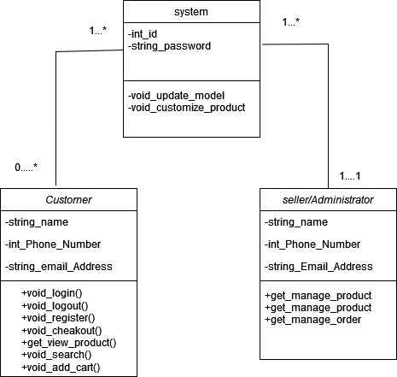

**2.Sequence Diagram:**

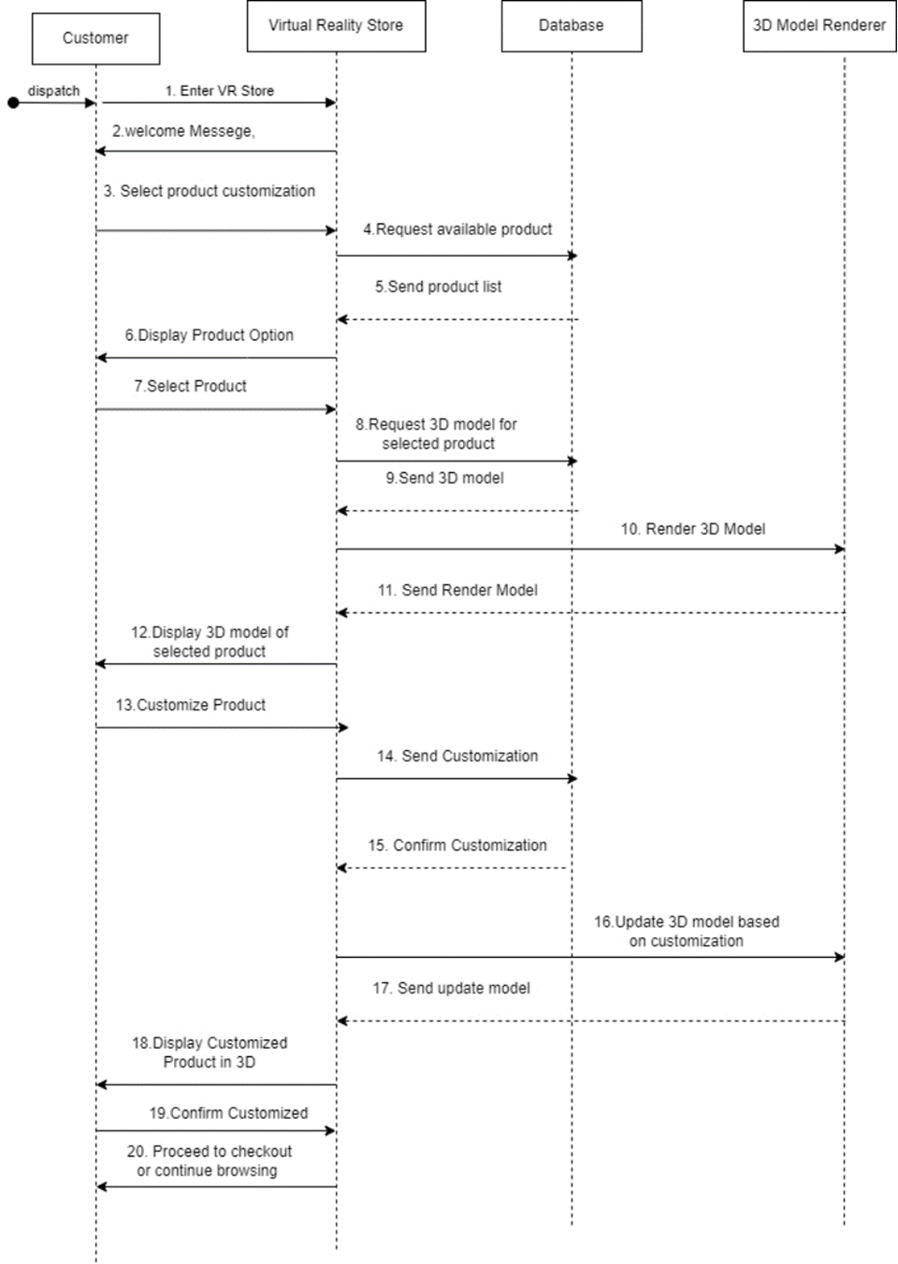

**3.ER- Diagram:**

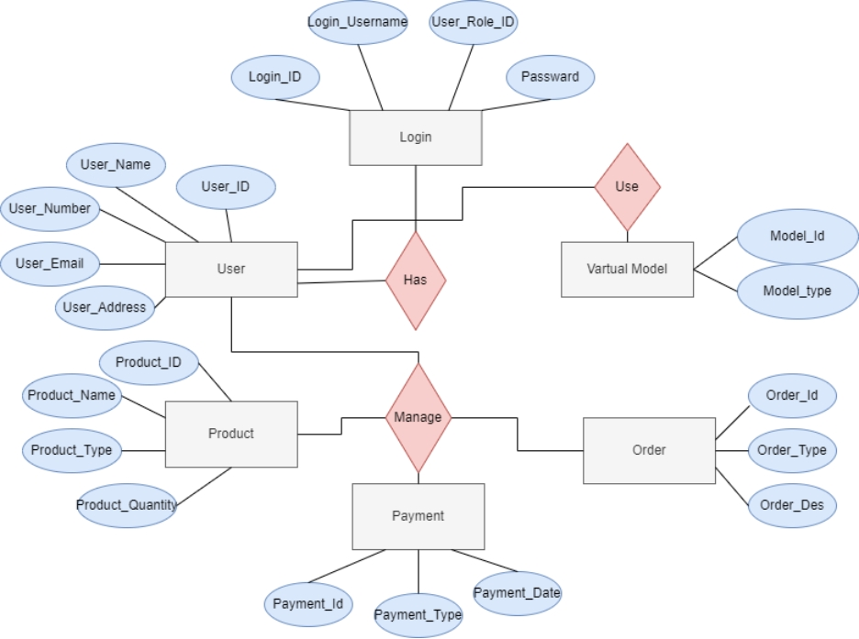

**4.Activity Diagram:**



**5.Use case Diagram:**

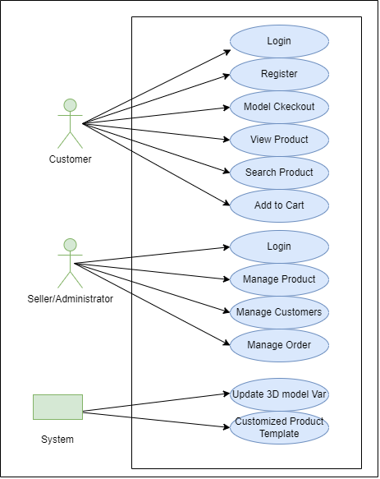

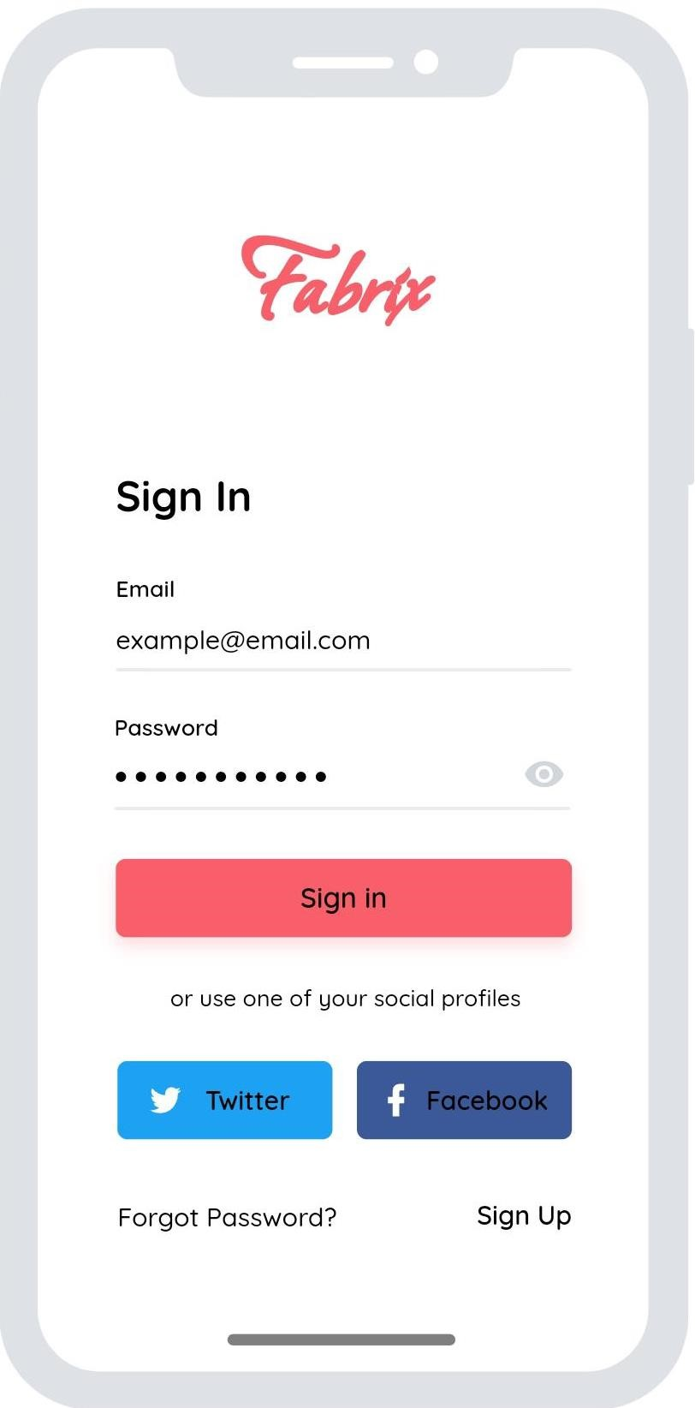Log in page

* By giving email and password Customer and Admin can sing in the application.
* If user provide a wrong password it gives a message to try again or click the forgot password.
* Also log in by using twitter and facebook account.
* Reset password by using forgot password .
* If there is no account in this application sign up first.

# Admin page

* 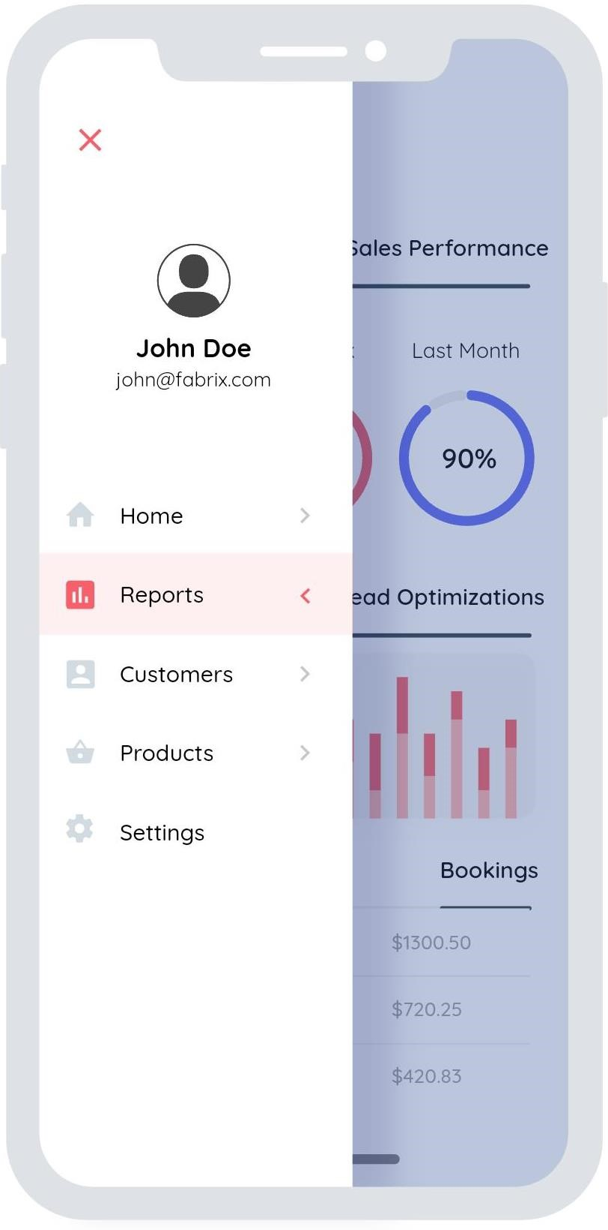Admin can upload customized product.
* Admin can see the report of sales department.
* Admin can see the customer response and review

# Report page (Admin page)

* Admin can see the daily ,weekly, monthly sales performance.
* Admin can also see the payment database of customer

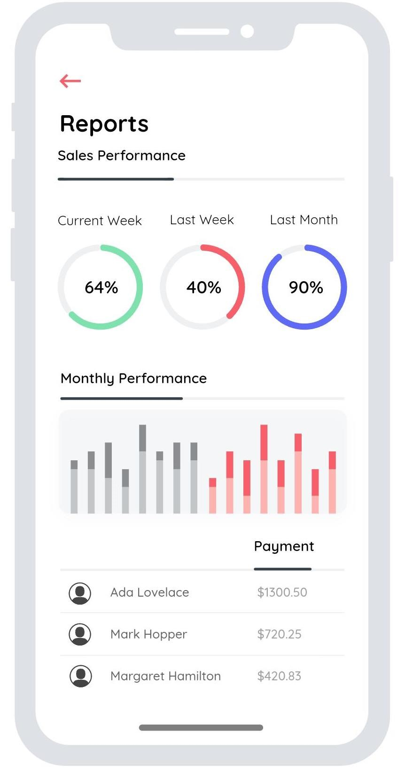

# Customer management page(Admin page)

* Admin can see the customer details database.
* Admin can search customer .
* Admin can ban or report customer for unusual activity.

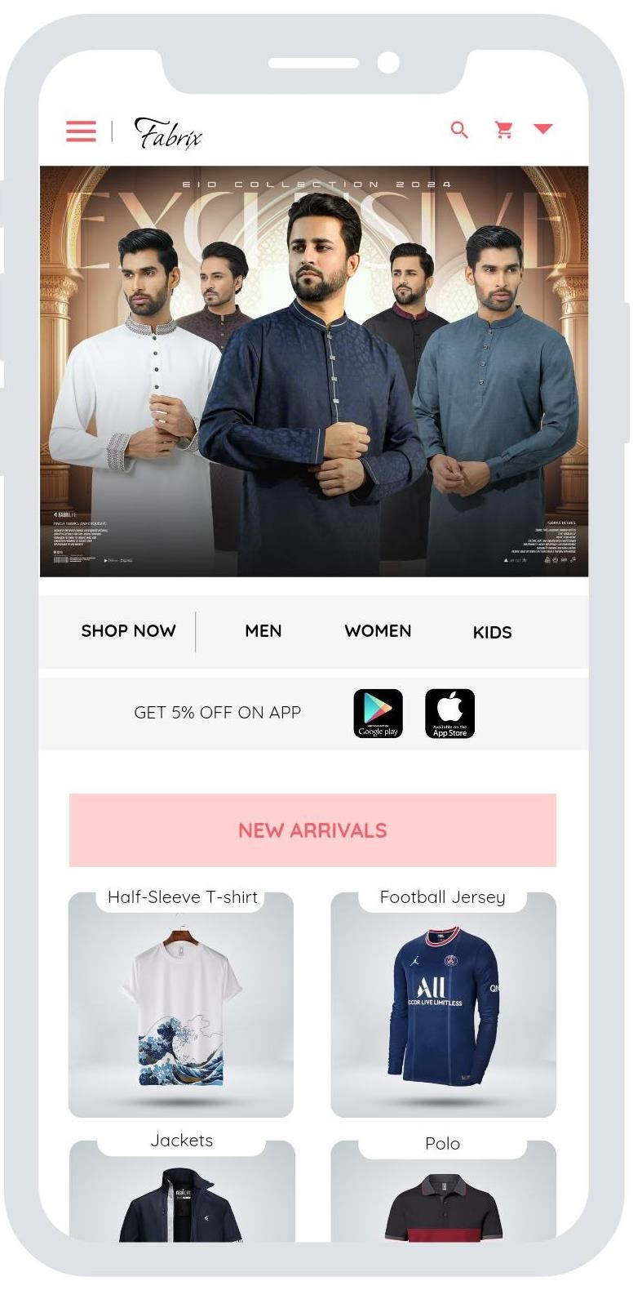

# Front/Landing page(Customer page)

* In top left there is a menu option where customer can see all the product list.
* Using the search button customer can search there desired product.
* In top-right corner there is a drop-down menu customer can go to his own profile or log-out.

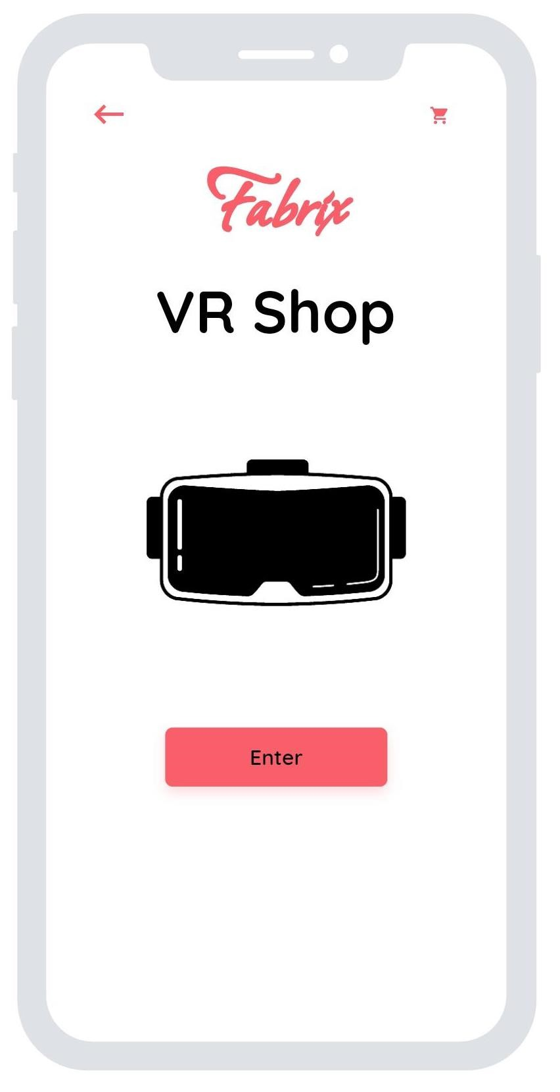

# VR page(Customer page)

* Using phone camera customer can scan the own body measurement.
* Also scan the avatar of any

# Customized avatar page(Customer page)

* Make a own avatar by giving the measurement of own body shape by customer .
* Customized the body shape .
* Add new attributes on customers body shape.

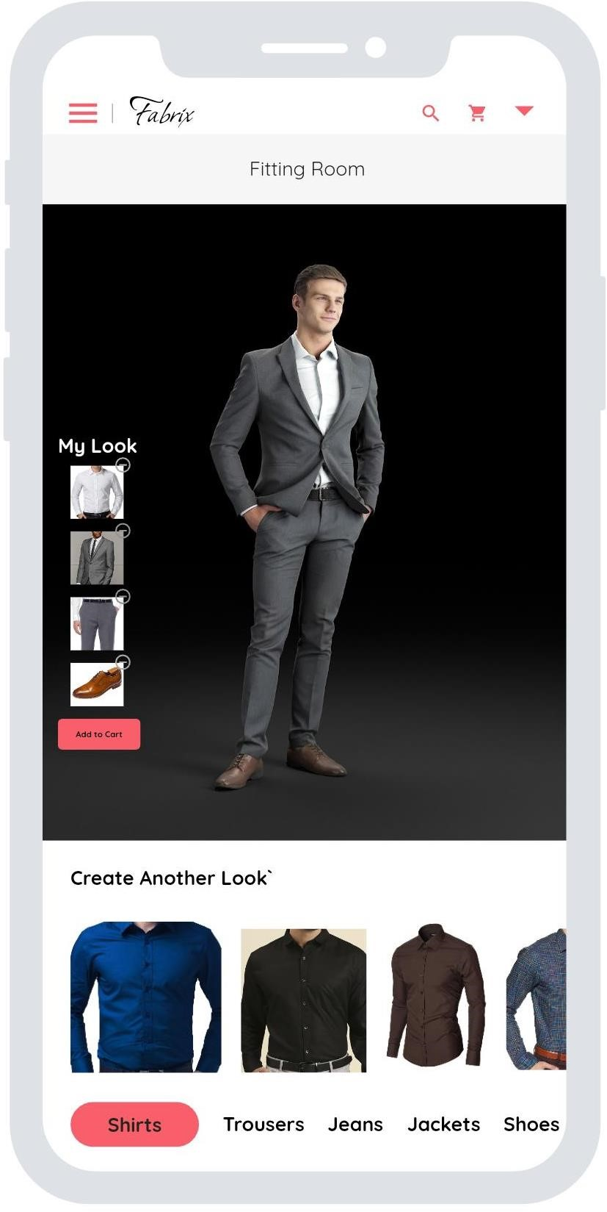

# Fitting room page(Customer page)

* Customer can choose the fabric and design.
* Create new look adding different type of wear.
* Customer can add different type of wear in his own avatar.

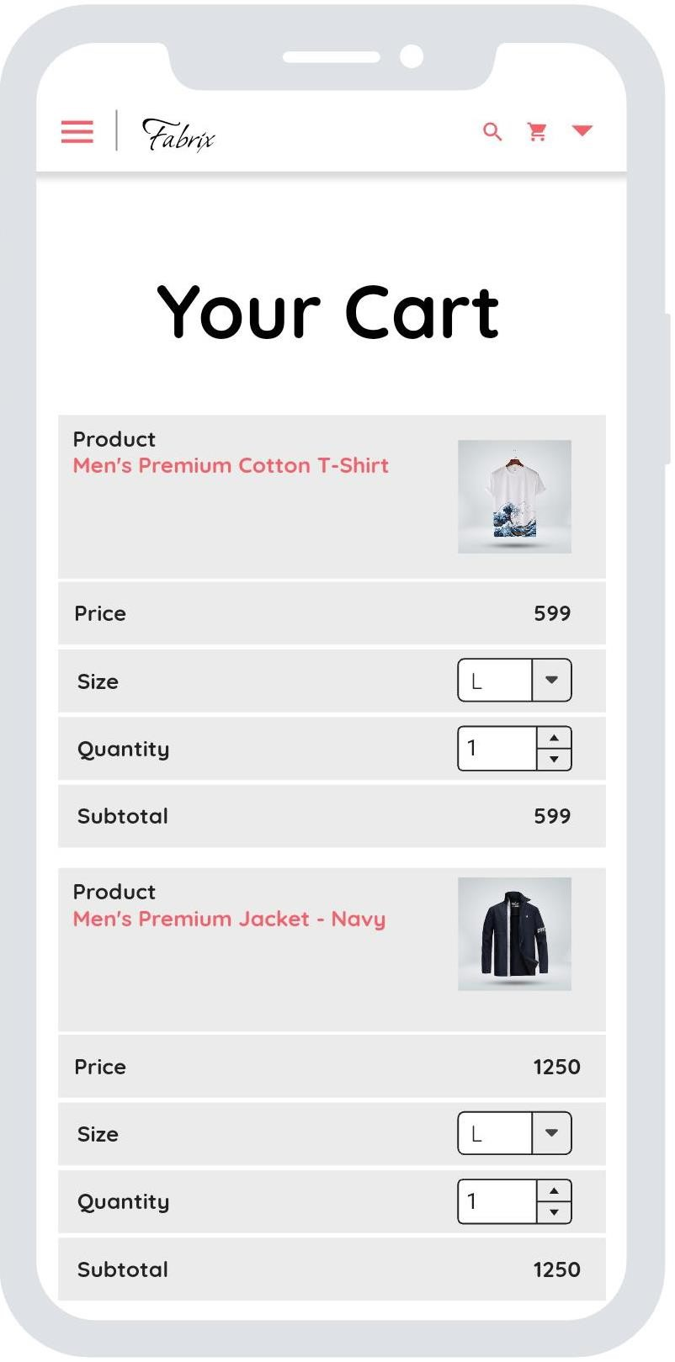

# Cart page (Customer page)

* After choosing or customizing the product customer can add into the cart .
* In cart page customer can see the price, size , quantity
* Customer can add multiple product in his cart option.

# Check out page(Customer page)

* After confirming the product customer order the product. Customer need to give the full name , email, phone number and address.
* Customer can choose the different type of payment option.
* After complete the given information customer can confirm the order by clicking the confirm order button.

|  |  |  |  |  |  |
| --- | --- | --- | --- | --- | --- |
| 3D model based product customization in virtual reality store | | | Sanviraj Aynul Siam | | |
|  | | | 15-04-24 | | |
|  | | | 17-04-24 | | |
| Module Name: **Rendering Test** | | | 18-04-24 | | |
| Test Title:Verify that the 3D model renders smoothly without any flickering or distortion during customization. | | | | | |
| Description: Test website rendering | | | | | |
| Precondition(If Any): Ensure that the textures and patterns applied during customization are displayed accurately | | | | | |
|  |  |  | |  |  |
| 2. Check renders smoothly or not | Flickering or distortion | lighting and shading are perfect | |  |  |
| Post Condition: the 3D model accurately reflects the selected customization options, including color, size, material, and any other modifications made by the user. | | | | | |

|  |  |  |  |  |  |
| --- | --- | --- | --- | --- | --- |
| 3D model based product customization in virtual reality store | | | Sanviraj Aynul Siam | | |
|  | | | 15-04-24 | | |
|  | | | 17-04-24 | | |
| Module Name: **Performance Test** | | | 18-04-24 | | |
| Test Title: Verify that the VR application remains responsive even during complex customization operations.. | | | | | |
| Description: Test website Performance | | | | | |
| Precondition(If Any): Ensure that the textures and patterns applied during customization are displayed accurately, make sure that the hardware setup including VR headsets, controllers, and any other peripherals are correctly connected and calibrated | | | | | |
|  |  |  | |  |  |
| 2. Check for memory leaks or performance | varying levels of hardware capabilities | VR store can handle the expected user traffic while delivering a satisfactory user experience." | |  |  |
| Post ConditionAfter the performance tests, comprehensive data and analysis should be available, detailing the application's response times, resource utilization, and scalability metrics under different load scenarios | | | | | |

|  |  |  |  |  |  |
| --- | --- | --- | --- | --- | --- |
| 3D model based product customization in virtual reality store | | | Sanviraj Aynul Siam | | |
|  | | | 15-04-24 | | |
|  | | | 17-04-24 | | |
| Module Name: **Compatibility Test** | | | 18-04-24 | | |
| Test Title: Verify that the application works seamlessly across various VR platforms (e.g., Oculus Store, SteamVR, PlayStation Store). | | | | | |
| Description: Test website Compatibility | | | | | |
| Precondition(If Any): Ensure that the VR application is compatible with different VR headsets (e.g., Oculus Rift, HTC Vive, PlayStation VR). | | | | | |
|  |  |  | |  |  |
| 2. Verify compatibility with VR headsets, controllers, and peripheral devices.  3. Test installation and functionality across VR platforms and operating systems.  4. Verify support for assistive technologies and compliance with accessibility standards. | **1. Hardware**  **Compatibility**  2. **Platform Compatibility**  3. **Browser Compatibility**  4. **Operating System Compatibility** | The VR store application seamlessly functions across diverse hardware, software, and user environments, ensuring a consistent and accessible experience for all users | | Not As expected | Fail |
| Post Condition: After identifying compatibility issues, thorough documentation of the encountered failures and their respective environments should be provided. | | | | | |

|  |  |  |  |  |  |
| --- | --- | --- | --- | --- | --- |
| 3D model based product customization in virtual reality store | | | Sanviraj Aynul Siam | | |
|  | | | 15-04-24 | | |
|  | | | 17-04-24 | | |
| Module Name: **Interactivity Test** | | | 18-04-24 | | |
| Test Title: Verify that users can interact with the 3D model using VR controllers or gestures. | | | | | |
| Description: Test website **Interactivity** | | | | | |
| Precondition(If Any): Ensure that users can undo/redo customization actions easily. | | | | | |
|  |  |  | |  |  |
| 2. Verify user interactions such as rotation, scaling, and modification of product attributes using VR controllers or gestures.  . | 1.Rotating the 3D model horizontally and vertically.  **2.** Scaling the 3D model up and down to adjust size.  **3** Test changing product attributes such as color, texture, and material. | User interactions with the 3D models are smooth, responsive, and accurately reflect changes made, ensuring a seamless customization experience. | | As expected | Pass |
| Post Condition: After the interactivity test, any identified issues related to responsiveness, accuracy, or smoothness of user interactions should be documented and addressed by the development team | | | | | |

|  |  |  |  |  |  |
| --- | --- | --- | --- | --- | --- |
| 3D model based product customization in virtual reality store | | | Sanviraj Aynul Siam | | |
|  | | | 15-04-24 | | |
|  | | | 17-04-24 | | |
| Module Name: **Save and Share Test** | | | 18-04-24 | | |
| Test Title: Verify that users can save their customized product configurations. | | | | | |
| Description: Test website Save and Share | | | | | |
| Precondition(If Any): Ensure that users can share their customized products via social media or email. | | | | | |
|  |  |  | |  |  |
| 2. Verify that users can save customized product configurations and share them via social media or email. | Test the functionality to load previously saved configurations for further customization. | users can save their customized product configurations seamlessly and share them via social media or email platforms | | Not As expected | Fail |
| Post Condition: The development team should prioritize resolving these issues to ensure that users can successfully save and share their customized product configurations. | | | | | |

|  |  |  |  |  |  |
| --- | --- | --- | --- | --- | --- |
| 3D model based product customization in virtual reality store. | | | Sarowar jahan protik. | | |
|  | | | 15-4-24 | | |
|  | | | 17-4-24 | | |
| Module Name:Cross-Browser Test. | | | 18-4-24 | | |
| Test Title:Cross-Browser Test Cases. | | | | | |
| Description:Cross-browser test cases ensure the VR store functions consistently across various web browsers, identifying and addressing any browser-specific rendering or interactivity issues. | | | | | |
| Pre-condition(if any):Before conducting cross-browser testing on the VR store, ensure that the web application is fully developed and operational. | | | | | |
|  |  |  | |  |  |
| 1. Identify Target Browsers 2. Execute Test Cases 3. Document Issues 4. Debug and Fix | Browser version. | Verify that the VR store loads correctly and all elements are displayed properly across different browsers. | | Actual results. | pass |
| Post condition:"After testing, make sure all problems found in specific browsers are fixed, so the VR store works the same on all browsers." | | | | | |

|  |  |  |  |  |  |
| --- | --- | --- | --- | --- | --- |
| 3D model based product customization in virtual reality store. | | | Sarowar jahan protik. | | |
|  | | | 15-4-24 | | |
|  | | | 17-4-24 | | |
| Module Name:Accessibility Test Case. | | | 18-4-24 | | |
| Test Title:Accessibility Test Case. | | | | | |
| Description:"Verify that all interactive elements on the webpage are operable using keyboard navigation,screen readers or voice command." | | | | | |
| Pre-condition(if any):"Ensure that the webpage being tested contains interactive elements such as buttons, links, or form fields." | | | | | |
|  |  |  | |  |  |
| 1. Verify accessibility of all interactive elements through keyboard navigation.  2. Test functionality of activating buttons, links, and form fields using keyboard inputs.  3.Validate compatibility and responsiveness of voice commands for interacting with elements.  4.Confirm seamless accessibility of form fields for input and submission via both keyboard and voice commands. | 1.Test data for keyboard navigation includes trying different keys like Tab, Enter, Arrow keys, and shortcuts to move around and interact with the webpage.  2.For testing voice commands, you'll want to try out different commands that relate to actions users might take on the webpage. | 1.Proper activation of buttons, links, and form fields using keyboard inputs.  2.Responsive execution of voice commands, triggering relevant actions on the webpage. | | Actual results. | pass |
| Post condition:The 3D model accurately make sure to note down any accessibility problems found, fix them, and double-check for compliance." | | | | | |

|  |  |  |  |  |  |
| --- | --- | --- | --- | --- | --- |
| 3D model based product customization in virtual reality store. | | | Sarowar jahan protik. | | |
|  | | | 15-4-24 | | |
|  | | | 17-4-24 | | |
| Module Name:Localization test case. | | | 18-4-24 | | |
| Test Title:Localization Test Case. | | | | | |
| Description:Localization test cases ensure software operates correctly in the target language by checking translation accuracy and display, along with functional adherence. | | | | | |
| Pre-condition(if any):Before localization testing, make sure the software is fully developed and set up for testing in the target language. | | | | | |
|  |  |  | |  |  |
| 1.Verify that the VR store supports multiple languages and locales.  2.Test the accuracy of translated text and localized content.  3.Ensure that cultural differences are considered in product customization options. | 1.Test data for localization testing consists of language-specific text, images, and formatting to check if the software functions correctly across different languages and regions. | 1.In localization testing, the expected outcome is for the software to show correct translations, suitable images, and meet formatting needs for the target language and region, ensuring a smooth user experience across different cultures and languages. | | Actual results. | pass |
| Post condition:Localization testing ensures that the software is accurately localized with all language-specific elements correctly implemented. | | | | | |

|  |  |  |  |  |  |
| --- | --- | --- | --- | --- | --- |
| 3D model based product customization in virtual reality store. | | | Sarowar jahan protik. | | |
|  | | | 15-4-24 | | |
|  | | | 17-4-24 | | |
| Module Name:Error Handling Test Cases. | | | 18-4-24 | | |
| Test Title:Error Handling Test Cases. | | | | | |
| Description:Testing the application's ability to gracefully handle errors and unexpected situations. | | | | | |
| Pre-condition(if any):Preconditions for error handling test cases establish the necessary environment and conditions required for executing the tests, including ensuring the application is running and any relevant data or configurations are in place. They serve as the foundation for evaluating how the application responds to various error scenarios and ensure consistent and reliable testing outcomes. | | | | | |
|  |  |  | |  |  |
| 1. Error messages . 2. Error scenario. 3.Disconnectivity and server error.   4.Losing customization. | 1.Verify that error messages are displayed clearly and help users understand how to resolve issues.  2.Test for error scenarios such as network disconnectivity or server errors.  3.Users should be able to recover from errors seamlessly, retaining their customization progress without any loss. | 1. The application detects the invalid input and displays an appropriate error message. 2. The application accurately identifies and handles the specific error scenario, preventing any unintended consequences or data corruption. 3. The application gracefully handles situations of disconnectivity and server errors, ensuring that users are informed of the issue and that their data is not lost or corrupted. 4. The application retains all user customizations and configurations even in error scenarios, ensuring that users do not lose their work or settings due to errors. | | Actual results. | pass |
| Post condition:The application remains in a stable state with all user customizations intact. | | | | | |

|  |  |  |  |  |  |
| --- | --- | --- | --- | --- | --- |
| 3D model based product customization in virtual reality store. | | | Sarowar jahan protik. | | |
|  | | | 15-4-24 | | |
|  | | | 17-4-24 | | |
| Module Name:Security Test Cases | | | 18-4-24 | | |
| Test Title:Security Test Cases | | | | | |
| Description:"Developing test cases to ensure the security features are robust and capable of withstanding potential threats." | | | | | |
| Pre-condition(if any):"System must be configured according to specifications.All necessary software and hardware components should be in place." | | | | | |
|  |  |  | |  |  |
| 1.1. Conduct injection attacks and cross-site scripting attempts.  2. Verify handling of user data and customization preferences.  3. Test user authentication with valid and invalid credentials.  4. Assess authorization mechanisms for access control. | 1.Test for vulnerabilities such as cross-site scripting (XSS) or injection attacks.  2.Verify that user data, including customization preferences, is handled securely.  3.Ensure that user authentication and authorization mechanisms are robust. | 1. Injection attacks and cross-site scripting attempts should be prevented.  2. Valid logins should grant access; invalid ones should be denied.  3. Only authorized users should access resources; unauthorized users should be blocked. | | Actual results. | pass |
| Post condition:"After completing security tests, ensure any identified vulnerabilities are fixed, and the system remains secure." | | | | | |

|  |  |  |  |  |  |
| --- | --- | --- | --- | --- | --- |
| Project Name: 3D Model Based Product Customization in VR Store. | | | | Test Designed by:  Md. Zahid Sadman Sakib | |
| Test Case ID: FR_1 | | | | Test Designed Date: 16/04/2024 | |
| Test Priority (Low, Medium, High): Medium  Module Name: Login Session | | | | Test Executed by:  Md. Zahid Sadman Sakib  Test Execution Date:  16/04/2024 | |
| Test Title: Verify login with valid username and password | | | | | |
| Description: Test website login page | | | | | |
| Pre-Condition (if any): User must have valid username and password | | | | | |
| Test Steps   1. Go to the website. 2. Enter Username 3. Enter Password 4. Click Submit | Test Data  Username:  999999999  Password:  321 | Expected Results  User should login to the application | Actual Results  As expected | | Status (Pass/Fail)  Pass |
| Post-Condition: User is validated with database and successfully login to the account. The account session details are recorded in the database. | | | | | |

|  |  |  |  |  |  |
| --- | --- | --- | --- | --- | --- |
| Project Name: 3D Model Based Product Customization in VR Store. | | | | Test Designed by:  Md. Zahid Sadman Sakib | |
| Test Case ID: FR_2 | | | | Test Designed Date: 16/04/2024 | |
| Test Priority (Low, Medium, High): Medium  Module Name: Login Session | | | | Test Executed by:  Md. Zahid Sadman Sakib  Test Execution Date:  16/04/2024 | |
| Test Title: Test password reset functionality | | | | | |
| Description: Test website login page | | | | | |
| Pre-Condition (if any): User may have forgotten their password. | | | | | |
| Test Steps   1. Click Reset Password. 2. Enter Username/Email 3. Follow the link sent to the email 4. Provide new password 5. Confirm new password | Test Data  Email:  zahid@gmail.com  New Password:  5475 | Expected Results  User should be able to reset password | Actual Results  as expected | | Status (Pass/Fail)  Pass |
| Post-Condition: New password is stored in database. User can login with new password | | | | | |

|  |  |  |  |  |  |
| --- | --- | --- | --- | --- | --- |
| Project Name: 3D Model Based Product Customization in VR Store. | | | | Test Designed by:  Md. Zahid Sadman Sakib | |
| Test Case ID: FR_3 | | | | Test Designed Date: 16/04/2024 | |
| Test Priority (Low, Medium, High): Medium  Module Name: Checkout Session | | | | Test Executed by:  Md. Zahid Sadman Sakib  Test Execution Date:  16/04/2024 | |
| Test Title: Check if the cart is working properly | | | | | |
| Description: Test checkout page | | | | | |
| Pre-Condition (if any): Users should be logged in to the website | | | | | |
| Test Steps   1. Search products. 2. Add products to cart. 3. Add desired quantity | Test Data  Product:  T-shirt  Quantity:  2 | Expected Results  User should add their desired item is added to the cart with the quantity they want | Actual Results  Not as expected | | Status (Pass/Fail)  Fail |
| Post-Condition: User’s selected products should remain in the cart even if they log out of their account. | | | | | |

|  |  |  |  |  |  |
| --- | --- | --- | --- | --- | --- |
| Project Name: 3D Model Based Product Customization in VR Store. | | | | Test Designed by:  Md. Zahid Sadman Sakib | |
| Test Case ID: FR_4 | | | | Test Designed Date: 16/04/2024 | |
| Test Priority (Low, Medium, High): Medium  Module Name: Login Session | | | | Test Executed by:  Md. Zahid Sadman Sakib  Test Execution Date:  16/04/2024 | |
| Test Title: Check for duplicate registration | | | | | |
| Description: Test website sign up page | | | | | |
| Pre-Condition (if any): User must have valid username and password | | | | | |
| Test Steps   1. Go to the website. 2. Enter Username/Email 3. Enter password 4. Click Submit | Test Data  Email:  zahid@gmail.com  Password:  321 | Expected Results  User should not be able to create new account | Actual Results  as expected | | Status (Pass/Fail)  Pass |
| Post-Condition: User signup information is checked against the database. If the account already exists user is asked to login instead. | | | | | |

|  |  |  |  |  |  |
| --- | --- | --- | --- | --- | --- |
| Project Name: 3D Model Based Product Customization in VR Store. | | | | Test Designed by:  Md. Zahid Sadman Sakib | |
| Test Case ID: FR_5 | | | | Test Designed Date: 16/04/2024 | |
| Test Priority (Low, Medium, High): Medium  Module Name: Login Session | | | | Test Executed by:  Md. Zahid Sadman Sakib  Test Execution Date:  16/04/2024 | |
| Test Title: Verify login with user’s social media account | | | | | |
| Description: Test website login page | | | | | |
| Pre-Condition (if any): User must have valid username and password | | | | | |
| Test Steps   1. Go to the website. 2. Select social media account. 3. Grant permission 4. Click Submit | Test Data  Platform:  Facebook  Username:  Zahid Sadman Nahid | Expected Results  User should login to the application | Actual Results  as expected | | Status (Pass/Fail)  Fail |
| Post-Condition: User is validated using the information from social media account and successfully login to the account. The account session details are recorded in the database. | | | | | |

|  |  |  |  |  |  |
| --- | --- | --- | --- | --- | --- |
| Project Name: 3D Model Based Product Customization in VR Store. | | | | Test Designed by:  Md. Shanjid Hasan Abir | |
| Test Case ID: FR_6 | | | | Test Designed Date: 16/04/2024 | |
| Test Priority (Low, Medium, High): Medium  Module Name: Payment Session | | | | Test Executed by:  Md. Shanjid Hasan Abir  Test Execution Date:  16/04/2024 | |
| Test Title: Check if payment process works properly | | | | | |
| Description: Test website payment page | | | | | |
| Pre-Condition (if any): User must logged in the website and must have product in the cart | | | | | |
| Test Steps   1. Click “Proceed to payment” 2. Choose payment method. 3. Provide account number of payment method. 4. Provide valid password of user payment account | Test Data  Platform:  Nogod  Account number:  018888888888  Password:  877078 | Expected Results  User should be able to pay price of the product | Actual Results  as expected | | Status (Pass/Fail)  Pass |
| Post-Condition: Showing a message to user for successful payment. Payment data is recorded in the database and user history. | | | | | |

|  |  |  |  |  |  |
| --- | --- | --- | --- | --- | --- |
| Project Name: 3D Model Based Product Customization in VR Store. | | | Test Designed by:  Md. Shanjid Hasan Abir | | |
| Test Case ID: FR_7 | | | Test Designed Date: 16/04/2024 | | |
| Test Priority (Low, Medium, High): Medium  Module Name: Product Management | | | Test Executed by:  Md. Shanjid Hasan Abir  Test Execution Date:  16/04/2024 | | |
| Test Title: Verify that an admin user is able to add a new product with valid details. | | | | | |
| Description: Test admin functionality | | | | | |
| Pre-Condition (if any): Admin is logged in. Admin is on the “Add Product” page. | | | | | |
| Test Steps   1. Enter a valid product name in the “Product Name” field. 2. Enter a valid description in the “Product Description” field. 3. Enter a valid price in the “Product Price” field. 4. Select a valid category from the “Product Category” dropdown. 5. Click on the “Submit” button. | Test Data  Product Name:  T-shirt  Category:  Men  Description:  Size: L  Availability:  50  Price:  560 | Expected Results  A success message saying “Product added successfully” should be displayed.  The new product should be listed in the product list. | | Actual Results  as expected | Status (Pass/Fail)  Pass |
| Post-Condition: The product database has one additional product. | | | | | |

|  |  |  |  |  |  |
| --- | --- | --- | --- | --- | --- |
| Project Name: 3D Model Based Product Customization in VR Store. | | | Test Designed by:  Md. Shanjid Hasan Abir | | |
| Test Case ID: FR_8 | | | Test Designed Date: 16/04/2024 | | |
| Test Priority (Low, Medium, High): Medium  Module Name: Reports and Analytics | | | Test Executed by:  Md. Shanjid Hasan Abir  Test Execution Date:  16/04/2024 | | |
| Test Title: Verify that an admin user is able to view the sales report with correct data. | | | | | |
| Description: Test admin functionality | | | | | |
| Pre-Condition (if any): Admin is logged in. Admin is on the “Sales Report” page. There have been some sales transactions in the system. | | | | | |
| Test Steps   1. Select a valid date range in the “Date Range” field. 2. Click on the “Generate Report” button. | Test Data  Start Date:  01/01/2024  End Date:  30/03/2024 | Expected Results  A sales report for the selected date range should be generated and displayed.  The report should include details such as total sales, number of transactions, average transaction value. | | Actual Results  as expected | Status (Pass/Fail)  Pass |
| Post-Condition: No changes to the system. | | | | | |

|  |  |  |  |  |  |
| --- | --- | --- | --- | --- | --- |
| Project Name: 3D Model Based Product Customization in VR Store. | | | Test Designed by:  Md. Shanjid Hasan Abir | | |
| Test Case ID: FR_9 | | | Test Designed Date: 16/04/2024 | | |
| Test Priority (Low, Medium, High): Medium  Module Name: Customer Management | | | Test Executed by:  Md. Shanjid Hasan Abir  Test Execution Date:  16/04/2024 | | |
| Test Title: Verify that an admin user is able to edit the details of an existing customer. | | | | | |
| Description: Test admin functionality | | | | | |
| Pre-Condition (if any): Admin is logged in. Admin is on the “Customer Details” page. There are existing customers in the system. | | | | | |
| Test Steps   1. Select an existing customer from the customer list. 2. Click on the “Edit” button. 3. Change the details in one or more fields (e.g., name, email, phone number). 4. Click on the “Save” button. | Test Data  Customer Name:  Sadman Sakib  Email:  Sadman02@gmail.com  Phone no:  018888888888 | Expected Results  A success message saying “Customer details updated successfully” should be displayed.  The changes should be reflected in the customer list and the customer’s profile. | | Actual Results  as expected | Status (Pass/Fail)  Pass |
| Post-Condition: The customer’s details in the database have been updated. | | | | | |

|  |  |  |  |  |  |
| --- | --- | --- | --- | --- | --- |
| Project Name: 3D Model Based Product Customization in VR Store. | | | Test Designed by:  Md. Shanjid Hasan Abir | | |
| Test Case ID: FR_10 | | | Test Designed Date: 16/04/2024 | | |
| Test Priority (Low, Medium, High): Medium  Module Name: User Authentication | | | Test Executed by:  Md. Shanjid Hasan Abir  Test Execution Date:  16/04/2024 | | |
| Test Title: Verify that the system can handle a high number of simultaneous login attempts. | | | | | |
| Description: Test admin functionality | | | | | |
| Pre-Condition (if any): There are multiple user accounts set up in the system. | | | | | |
| Test Steps   1. Simulate a large number of users (e.g., 10,000) attempting to log in at the same time. 2. Monitor system performance, error rate, and response time during the test. | Test Data  Log-in information of 12000 customers | Expected Results  The system should be able to handle the load without crashing or becoming unresponsive.  The error rate should not exceed an acceptable threshold (this threshold would be defined based on system requirements).  The response time for each login attempt should not exceed an acceptable threshold (again, this threshold would be defined based on system requirements). | | Actual Results  Not as expected | Status (Pass/Fail)  Fail |
| Post-Condition: The system remains stable and responsive. | | | | | |

**Work Break-Down Structure (WBS)**

**COCOMO**

We are using COCOMO which is the only type of static model that can quickly and roughly estimate software development effort. It primarily deals with the number of line of code, and the level of estimation accuracy is low because we do not consider all project parameters. The relation: gives the estimated effort and scheduled time for project:

Based on SLOC characteristics, and operates according to the following equations:

# Effort =PM=Coefficient<Effort Factor>*(SLOC/1000)^P

[100,000 SLOC/1000 = 100k SLOC]

# Development time = DM =2.52*(PM)^T

* **Required number of people = ST =PM/DM**

**PM** : person-months needed for project (labor working hours)

**SLOC**: source lines of code

**P** : project complexity (1.04-1.24)

**DM**: duration time in months for project(week days)

**T**: SLOC-dependent coefficient (0.32-0.38)

**ST**: average staffing necessary

|  |  |  |  |
| --- | --- | --- | --- |
| **Software Project Type** | **Coefficient**  **<Effort Factor>** | **P** | **T** |
| Organic | 2.8 | 1.06 | 0.38 |
| Semi-detached | 3.2 | 1.14 | 0.36 |
| Embedded | 3.8 | 1.25 | 0.34 |

**Constructive Cost Model:**

Assume that our project has 6000 lines od codes .So, the organic value of the **“Online Car Parking Rental System”** is

SLOC = 6000

P = 1.05 (Embedded)

T = 0.38

Coefficient = 2.4

Effort = PM = Coefficient<Effort Factor>*(SLOC/1000) ^P

= 2.4 * (6000/1000) ^1.05

= 15.75

Development time = DM = 2.50*(PM)^T

=2.50*(15.75)^0.38 =7.14

= 7

Required number of people = ST = PM/DM

= 15.75/7

= 2.25 = 3

Here, 10 tasks have been completed.

Here,

BCWP=100.5

BCWS=144.5

ACWP=120.5

Here,

BAC=15.749*22

=346.5

SPI = BCWP/BCWS

=100.5/144.5

=0.69

SV= BCWP-BCWS

=100.5-144.5

= -44 person-day

CPI= BCWP/ACWP

=100.5/102.5

= 0.98

CV= BCWP-ACWP

=100.5- 102.5

= -2 person-day

% Schedule for completing = BCWS/BAC

= 144.5/346.5

=41.7%

[ % of work schedule to be done at this time]

% complete = BCWP/BAC

=100.5/346.5

=29%

[% of work completes at this time]

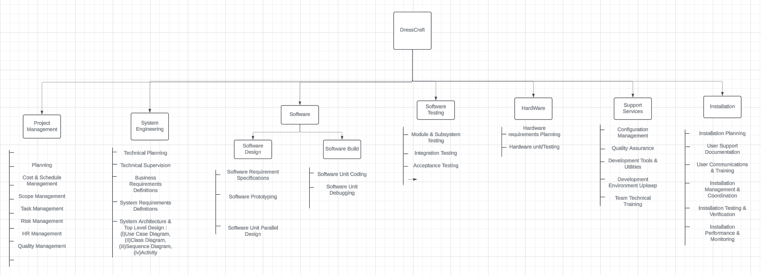

Fabrix

**Timeline Chart 1:**

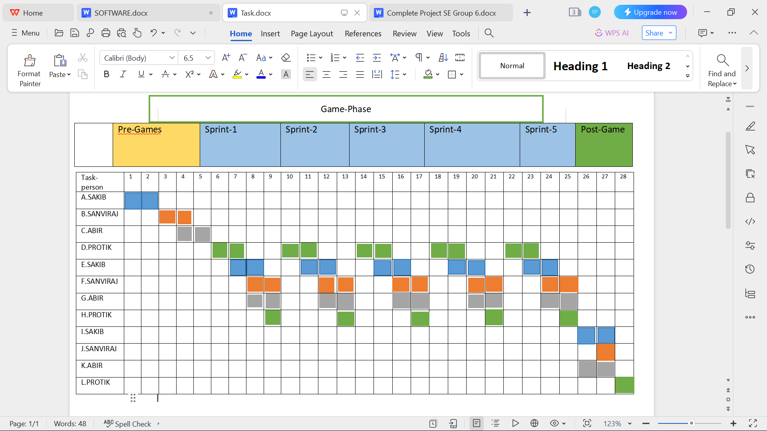

A: Conceptual Planning, Finalize Project Scope, objectives and high-level requirements.

B: Establish architectural groundwork, tool selection and team roles.

C: Analysis, Planning.

D: Analysis J: System Testing

E: Design K: Documentation

F: Coding L: Release

G: Functional Testing

H: Product Backlog Update

I: Integration

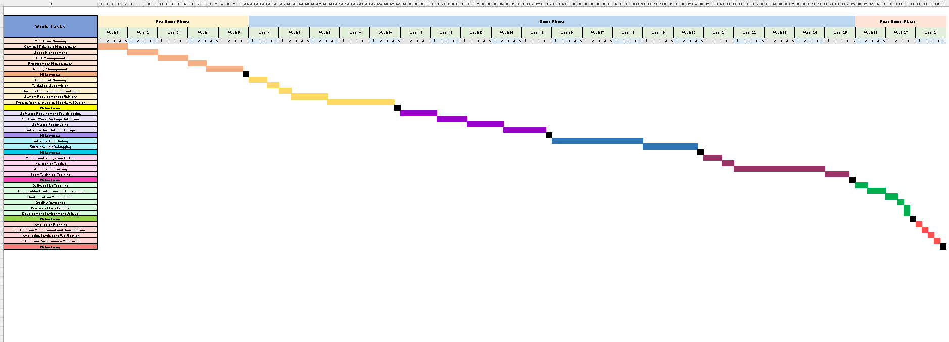

## Risk Management

|  |  |  |  |  |
| --- | --- | --- | --- | --- |
| Risks | Category | Probability | Impact | RMMM |
| Size estimate may be significantly low | PS | 60% | 2 | Mitigation: Use  expert judgment and historical data for better estimation.  Monitoring:  Regularly review task progress against estimates. Management: Adjust scope and timelines based on revised  estimates. |
| Larger number of users than planned | PS | 30% | 3 | Mitigation: Design  scalable system architectures.  Monitoring: Keep track of user  registration and activity.  Management: Increase server capacity and  optimize software. |
| Less reuse than planned | PS | 70% | 2 | Mitigation: Promote  modular design. Monitoring: Track code reuse metrics. Management: Allocate time for refactoring and  module generalization. |
| End-users resist system | BU | 40% | 3 | Mitigation: Involve  users early in requirement and design phases. Monitoring: Gather user feedback frequently.  Management:  Conduct usability enhancements based on feedback. |

|  |  |  |  |  |
| --- | --- | --- | --- | --- |
| Delivery deadline will be tightened | BU | 50% | 2 | Mitigation: Add buffer periods in the schedule.  Monitoring: Regular milestone reviews. Management: Re- prioritize features  based on available time. |
| Funding will be lost | CU | 40% | 1 | Mitigation: Secure  funding agreements and explore  contingency funds. Monitoring: Regular financial health checks.  Management: Scale project scope based  on available budget. |
| Customer will change requirements | PS | 80% | 2 | Mitigation: Use agile  methods to accommodate changes.  Monitoring:  Regularly review changes and their impacts.  Management:  Formal change control processes  and re-estimation. |
| Technology will not meet expectations | TE | 30% | 1 | Mitigation: Conduct  early prototype testing. Monitoring:  Continual technology performance evaluations.  Management: Have backup  technologies and vendors in case of failure. |
| Lack of training on tools | DE | 80% | 3 | Mitigation: Schedule regular training sessions.  Monitoring: Assess team competency levels. Management:  Provide resources for ongoing education and support. |
| Staff inexperienced | ST | 30% | 2 | Mitigation: Mix  teams with junior and senior developers.  Monitoring: Review work quality regularly.  Management:  Provide mentorship and further training. |
| Staff turnover will be high | ST | 60% | 2 | Mitigation: Enhance  job satisfaction and work environment. Monitoring: Keep track of staff morale and turnover rates. Management: Prepare for quick  replacements and knowledge transfer. |
| Integration complexities | TE | 60% | 2 | Mitigation: Design  integration tests early. Monitoring: Regular integration testing sessions.  Management: Allocate extra time and resources for potential integration  issues. |

|  |  |  |  |  |
| --- | --- | --- | --- | --- |
| Legal and compliance issues | BU | 25% | 2 | Mitigation: Consult compliance experts during design.  Monitoring: Regular compliance reviews. Management: Adjust project practices based on legal  advice. |
| Data security breaches | TE | 50% | 1 | Mitigation:  Implement robust security protocols. Monitoring: Conduct regular security audits.  Management:  Immediate response team for breaches. |
| Hardware failures | TE | 30% | 3 | Mitigation: Use high- quality, redundant hardware.  Monitoring: Regular hardware checks. Management: Ǫuick hardware replacement  strategy. |

Impact Values

1. Catastrophic
2. Critical
3. Marginal
4. Negligible
5. The work product is called a Risk Mitigation , Monitoring , And Management plan (RMMM)

## Allocation

Project Management:

* Project Manager: Responsible for overall project planning, coordination, and stakeholder management.

Development Team:

* VR Developer: Develops the virtual reality environment and interactions.
* 3D Modeler: Creates customizable 3D models of products.
* UI/UX Designer: Designs the user interface for the virtual reality store.
* Backend Developer: Implements the backend systems for product customization and data management.
* Frontend Developer: Implements the frontend features and interactions within the virtual reality environment.

Testing and Quality Assurance:

* QA Lead: Leads testing efforts to ensure the virtual reality store functions correctly.
* Test Analyst: Writes test cases and executes functional and non-functional tests.
* QA Engineers: Assist in test execution and defect tracking.

Deployment and Maintenance:

* Deployment Manager: Plans and coordinates the deployment of the virtual reality store.
* System Administrators: Responsible for maintaining server infrastructure.
* Deployment Engineers: Assist in deployment activities and software updates.

Customer Support and Training:

* Training Specialist: Develops user guides and conducts training sessions for customers using the virtual reality store.
* Support Engineers: Provide ongoing support and address user feedback and issues.